Hands On - Data Summarization
Missing Values, Frequency Distributions, Histograms, Box Plots & Outlier Detection with Real Kaggle Datasets
Dated: 6th August 2026

1. Complete Summary of an Employee Dataset
Dataset: IBM HR Analytics Employee Attrition & Performance (1,470 rows, 35 columns) — Kaggle: https://www.kaggle.com/datasets/pavansubhasht/ibm-hr-analytics-attrition-dataset
Code
# Dataset: IBM HR Analytics Employee Attrition & Performance
# Kaggle: https://www.kaggle.com/datasets/pavansubhasht/ibm-hr-analytics-attrition-dataset
import kagglehub
import pandas as pd
# Download the latest version of the dataset from Kaggle
path = kagglehub.dataset_download("pavansubhasht/ibm-hr-analytics-attrition-dataset")
df = pd.read_csv(path + "/WA_Fn-UseC_-HR-Employee-Attrition.csv")
print("Number of rows:", df.shape[0])
print("Number of columns:", df.shape[1])
print("\nData Types:")
print(df.dtypes)
print("\nMissing Values:")
print(df.isnull().sum())
print("\nStatistical Summary:")
print(df.describe())
Output
Number of rows: 1470
Number of columns: 35
Data Types:
Age int64
Attrition str
BusinessTravel str
DailyRate int64
Department str
DistanceFromHome int64
Education int64
EducationField str
EmployeeCount int64
EmployeeNumber int64
EnvironmentSatisfaction int64
Gender str
HourlyRate int64
JobInvolvement int64
JobLevel int64
JobRole str
JobSatisfaction int64
MaritalStatus str
MonthlyIncome int64
MonthlyRate int64
NumCompaniesWorked int64
Over18 str
OverTime str
PercentSalaryHike int64
PerformanceRating int64
RelationshipSatisfaction int64
StandardHours int64
StockOptionLevel int64
TotalWorkingYears int64
TrainingTimesLastYear int64
WorkLifeBalance int64
YearsAtCompany int64
YearsInCurrentRole int64
YearsSinceLastPromotion int64
YearsWithCurrManager int64
dtype: object
Missing Values:
Age 0
Attrition 0
BusinessTravel 0
DailyRate 0
Department 0
DistanceFromHome 0
Education 0
EducationField 0
EmployeeCount 0
EmployeeNumber 0
EnvironmentSatisfaction 0
Gender 0
HourlyRate 0
JobInvolvement 0
JobLevel 0
JobRole 0
JobSatisfaction 0
MaritalStatus 0
MonthlyIncome 0
MonthlyRate 0
NumCompaniesWorked 0
Over18 0
OverTime 0
PercentSalaryHike 0
PerformanceRating 0
RelationshipSatisfaction 0
StandardHours 0
StockOptionLevel 0
TotalWorkingYears 0
TrainingTimesLastYear 0
WorkLifeBalance 0
YearsAtCompany 0
YearsInCurrentRole 0
YearsSinceLastPromotion 0
YearsWithCurrManager 0
dtype: int64
Statistical Summary:
Age DailyRate ... YearsSinceLastPromotion YearsWithCurrManager
count 1470.000000 1470.000000 ... 1470.000000 1470.000000
mean 36.923810 802.485714 ... 2.187755 4.123129
std 9.135373 403.509100 ... 3.222430 3.568136
min 18.000000 102.000000 ... 0.000000 0.000000
25% 30.000000 465.000000 ... 0.000000 2.000000
50% 36.000000 802.000000 ... 1.000000 3.000000
75% 43.000000 1157.000000 ... 3.000000 7.000000
max 60.000000 1499.000000 ... 15.000000 17.000000
[8 rows x 26 columns]

2. Frequency Distribution of Students' Grades (Bar Chart)
Dataset: Students Performance in Exams (1,000 rows) — Kaggle: https://www.kaggle.com/datasets/spscientist/students-performance-in-exams
Code
# Dataset: Students Performance in Exams
# Kaggle: https://www.kaggle.com/datasets/spscientist/students-performance-in-exams
import kagglehub
import pandas as pd
import matplotlib.pyplot as plt
# Download the latest version of the dataset from Kaggle
path = kagglehub.dataset_download("spscientist/students-performance-in-exams")
df = pd.read_csv(path + "/StudentsPerformance.csv")
# Convert numeric math score into letter grades
def to_grade(score):
if score >= 90: return "A"
elif score >= 80: return "B"
elif score >= 70: return "C"
elif score >= 60: return "D"
else: return "F"
df["grade"] = df["math score"].apply(to_grade)
# Frequency distribution of grades
grade_freq = df["grade"].value_counts().sort_index()
print("Frequency Distribution of Grades:")
print(grade_freq)
# Bar chart
plt.figure(figsize=(7, 5))
plt.bar(grade_freq.index, grade_freq.values, color="steelblue")
plt.title("Frequency Distribution of Student Grades (Math Score)")
plt.xlabel("Grade")
plt.ylabel("Number of Students")
plt.tight_layout()
plt.show()
Output
Frequency Distribution of Grades:
grade
A 58
B 135
C 216
D 268
F 323
Name: count, dtype: int64
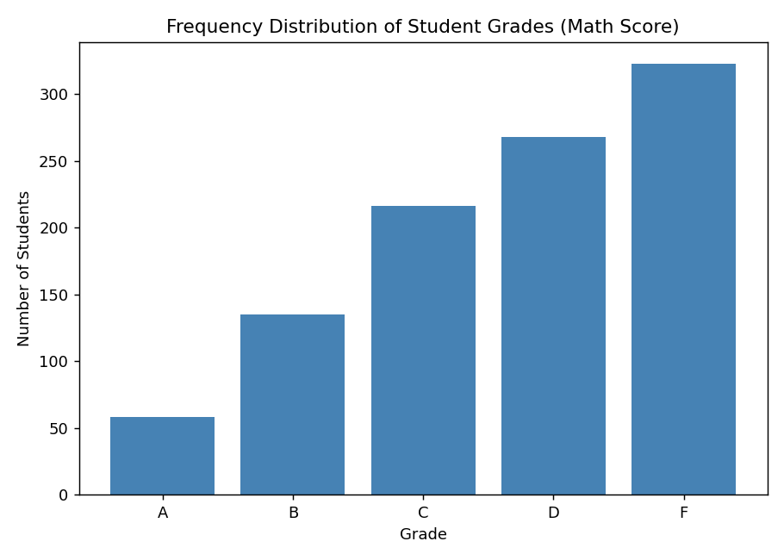

3. Histogram of House Prices — Normal or Skewed?
Dataset: House Sales in King County, USA (21,613 rows) — Kaggle: https://www.kaggle.com/datasets/harlfoxem/housesalesprediction
Code
# Dataset: House Sales in King County, USA
# Kaggle: https://www.kaggle.com/datasets/harlfoxem/housesalesprediction
import kagglehub
import pandas as pd
import matplotlib.pyplot as plt
from scipy.stats import skew
# Download the latest version of the dataset from Kaggle
path = kagglehub.dataset_download("harlfoxem/housesalesprediction")
df = pd.read_csv(path + "/kc_house_data.csv")
# Plot histogram of house prices
plt.figure(figsize=(8, 5))
plt.hist(df["price"], bins=60, color="teal", edgecolor="black")
plt.title("Distribution of House Prices")
plt.xlabel("Price ($)")
plt.ylabel("Number of Houses")
plt.tight_layout()
plt.show()
# Check skewness
price_skew = skew(df["price"])
print("Skewness of house price distribution:", round(price_skew, 3))
if price_skew > 0.5:
print("The data is right-skewed (positively skewed).")
elif price_skew < -0.5:
print("The data is left-skewed (negatively skewed).")
else:
print("The data is approximately normally distributed.")
Output
Skewness of house price distribution: 4.021
The data is right-skewed (positively skewed).
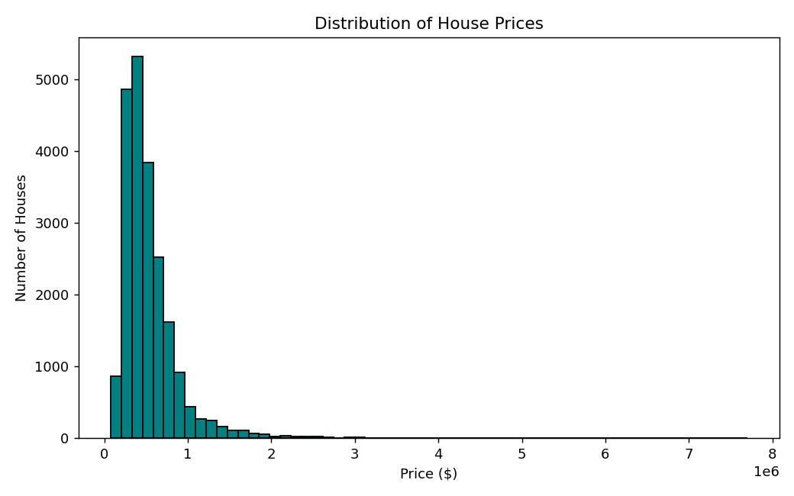

4. Box Plot of Salary Data — Outlier Detection
Dataset: Salary Data - Simple Linear Regression — Kaggle: https://www.kaggle.com/datasets/karthickveerakumar/salary-data-simple-linear-regression
Code
# Dataset: Salary Data - Simple Linear Regression
# Kaggle: https://www.kaggle.com/datasets/karthickveerakumar/salary-data-simple-linear-regression
import kagglehub
import pandas as pd
import matplotlib.pyplot as plt
# Download the latest version of the dataset from Kaggle
path = kagglehub.dataset_download("karthickveerakumar/salary-data-simple-linear-regression")
df = pd.read_csv(path + "/Salary_Data.csv")
# Box plot of salary data
plt.figure(figsize=(6, 6))
plt.boxplot(df["Salary"], vert=True, patch_artist=True,
boxprops=dict(facecolor="lightblue"))
plt.title("Box Plot of Salary Data")
plt.ylabel("Salary ($)")
plt.tight_layout()
plt.show()
# Identify outliers using the IQR method
Q1 = df["Salary"].quantile(0.25)
Q3 = df["Salary"].quantile(0.75)
IQR = Q3 - Q1
lower_bound = Q1 - 1.5 * IQR
upper_bound = Q3 + 1.5 * IQR
outliers = df[(df["Salary"] < lower_bound) | (df["Salary"] > upper_bound)]
print(f"Q1: {Q1}, Q3: {Q3}, IQR: {IQR}")
print(f"Lower bound: {lower_bound}, Upper bound: {upper_bound}")
print(f"Number of outliers detected: {len(outliers)}")
print(outliers)
Output
Q1: 56878.25, Q3: 95023.25, IQR: 38145.0
Lower bound: -339.25, Upper bound: 152240.75
Number of outliers detected: 0
Empty DataFrame
Columns: [Experience Years, Salary]
Index: []
No points fall outside the whiskers — this particular Salary dataset is naturally clean, with zero IQR-flagged outliers.
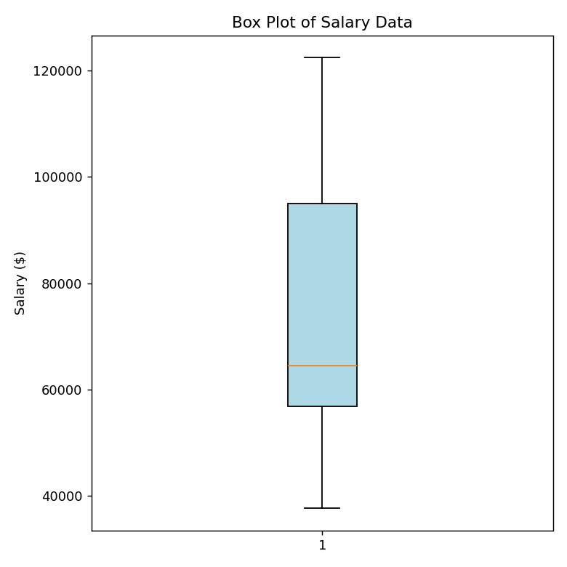

5. Detecting Outliers in Students' Marks (IQR Method)
Dataset: Students Performance in Exams — Kaggle: https://www.kaggle.com/datasets/spscientist/students-performance-in-exams
Code
# Dataset: Students Performance in Exams
# Kaggle: https://www.kaggle.com/datasets/spscientist/students-performance-in-exams
import kagglehub
import pandas as pd
# Download the latest version of the dataset from Kaggle
path = kagglehub.dataset_download("spscientist/students-performance-in-exams")
df = pd.read_csv(path + "/StudentsPerformance.csv")
# Detect outliers in math score using the IQR method
Q1 = df["math score"].quantile(0.25)
Q3 = df["math score"].quantile(0.75)
IQR = Q3 - Q1
lower_bound = Q1 - 1.5 * IQR
upper_bound = Q3 + 1.5 * IQR
outliers = df[(df["math score"] < lower_bound) | (df["math score"] > upper_bound)]
print(f"Q1: {Q1}, Q3: {Q3}, IQR: {IQR}")
print(f"Lower bound: {lower_bound}, Upper bound: {upper_bound}")
print(f"Number of outlier students detected: {len(outliers)}")
print(outliers[["gender", "math score", "reading score", "writing score"]])
Output
Q1: 57.0, Q3: 77.0, IQR: 20.0
Lower bound: 27.0, Upper bound: 107.0
Number of outlier students detected: 8
gender math score reading score writing score
17 female 18 32 28
59 female 0 17 10
145 female 22 39 33
338 female 24 38 27
466 female 26 31 38
787 female 19 38 32
842 female 23 44 36
980 female 8 24 23

6. Removing Outliers from a Sales Dataset (IQR Method)
Dataset: House Sales in King County, USA (house sale-price data) — Kaggle: https://www.kaggle.com/datasets/harlfoxem/housesalesprediction
Code
# Dataset: House Sales in King County, USA
# Kaggle: https://www.kaggle.com/datasets/harlfoxem/housesalesprediction
import kagglehub
import pandas as pd
# Download the latest version of the dataset from Kaggle
path = kagglehub.dataset_download("harlfoxem/housesalesprediction")
df = pd.read_csv(path + "/kc_house_data.csv")
print("Original dataset shape:", df.shape)
# Remove outliers from the 'price' column using the IQR method
Q1 = df["price"].quantile(0.25)
Q3 = df["price"].quantile(0.75)
IQR = Q3 - Q1
lower_bound = Q1 - 1.5 * IQR
upper_bound = Q3 + 1.5 * IQR
cleaned_df = df[(df["price"] >= lower_bound) & (df["price"] <= upper_bound)]
print("Lower bound:", lower_bound, " Upper bound:", upper_bound)
print("Cleaned dataset shape:", cleaned_df.shape)
print("Rows removed:", df.shape[0] - cleaned_df.shape[0])
print("\nCleaned dataset preview:")
print(cleaned_df[["id", "date", "price", "bedrooms", "bathrooms", "sqft_living"]].head())
# Save the cleaned dataset
cleaned_df.to_csv("kc_house_data_cleaned.csv", index=False)
print("\nCleaned dataset saved as kc_house_data_cleaned.csv")
Output
Original dataset shape: (21613, 21)
Lower bound: -162625.0 Upper bound: 1129575.0
Cleaned dataset shape: (20454, 21)
Rows removed: 1159
Cleaned dataset preview:
ID Date Price Bedrooms Bathrooms Sqft_living
0 1 20140916T000000 280000.0 6 3.00 2400
1 2 20150422T000000 300000.0 6 3.00 2400
2 3 20140508T000000 647500.0 4 1.75 2060
3 4 20140811T000000 400000.0 3 1.00 1460
4 5 20150401T000000 235000.0 3 1.00 1430
Cleaned dataset saved as kc_house_data_cleaned.csv

7. Histograms & Box Plots Before / After Outlier Removal
Dataset: 50 Startups (Profit) — Kaggle: https://www.kaggle.com/datasets/farhanmd29/50-startups
Code
# Dataset: 50 Startups
# Kaggle: https://www.kaggle.com/datasets/farhanmd29/50-startups
import kagglehub
import pandas as pd
import matplotlib.pyplot as plt
# Download the latest version of the dataset from Kaggle
path = kagglehub.dataset_download("farhanmd29/50-startups")
df = pd.read_csv(path + "/50_Startups.csv")
# Detect and remove outliers in 'Profit' using the IQR method
Q1 = df["Profit"].quantile(0.25)
Q3 = df["Profit"].quantile(0.75)
IQR = Q3 - Q1
lower_bound = Q1 - 1.5 * IQR
upper_bound = Q3 + 1.5 * IQR
cleaned_df = df[(df["Profit"] >= lower_bound) & (df["Profit"] <= upper_bound)]
print(f"Original rows: {len(df)} Cleaned rows: {len(cleaned_df)}")
print(f"Outliers removed: {len(df) - len(cleaned_df)}")
# Histograms and box plots before and after outlier removal
fig, axes = plt.subplots(2, 2, figsize=(12, 9))
axes[0, 0].hist(df["Profit"], bins=15, color="steelblue", edgecolor="black")
axes[0, 0].set_title("Histogram - Before Outlier Removal")
axes[0, 0].set_xlabel("Profit ($)")
axes[0, 1].hist(cleaned_df["Profit"], bins=15, color="seagreen", edgecolor="black")
axes[0, 1].set_title("Histogram - After Outlier Removal")
axes[0, 1].set_xlabel("Profit ($)")
axes[1, 0].boxplot(df["Profit"], patch_artist=True, boxprops=dict(facecolor="lightblue"))
axes[1, 0].set_title("Box Plot - Before Outlier Removal")
axes[1, 0].set_ylabel("Profit ($)")
axes[1, 1].boxplot(cleaned_df["Profit"], patch_artist=True, boxprops=dict(facecolor="lightgreen"))
axes[1, 1].set_title("Box Plot - After Outlier Removal")
axes[1, 1].set_ylabel("Profit ($)")
plt.tight_layout()
plt.show()
Output
Original rows: 50 Cleaned rows: 49
Outliers removed: 1
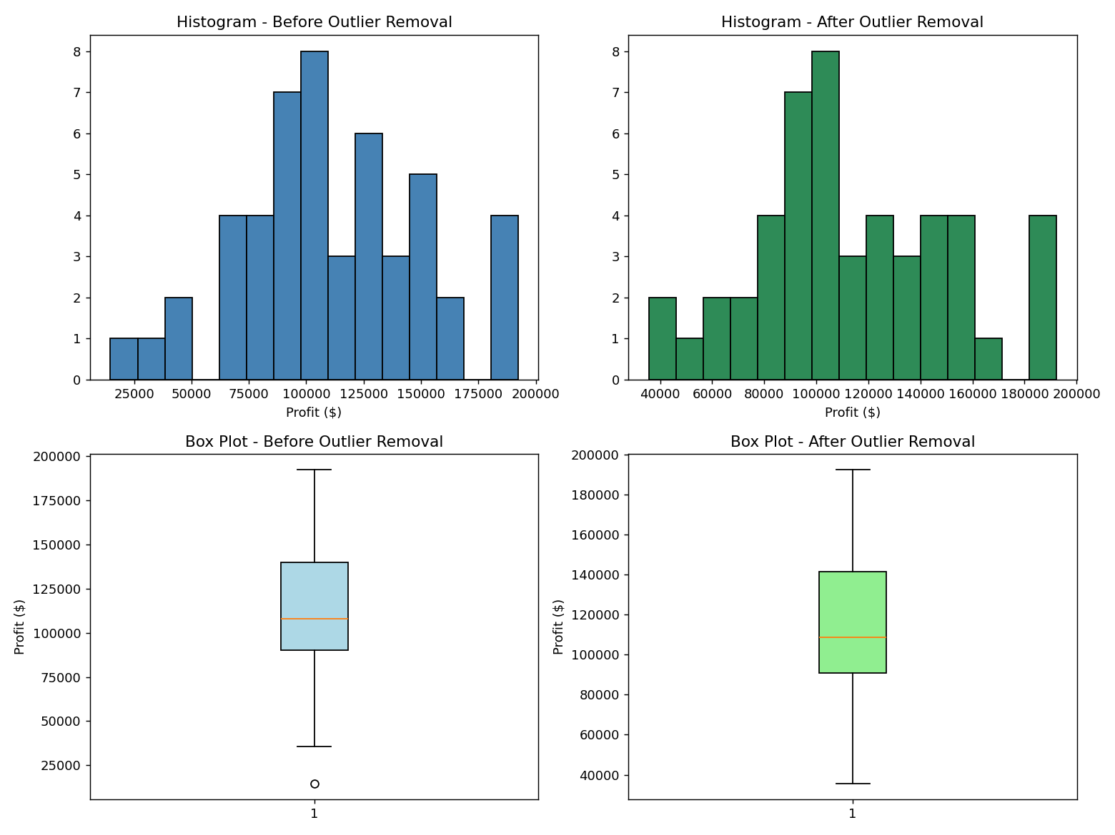

8. Full Exploratory Data Analysis — Titanic Dataset
Dataset: Titanic Dataset (891 rows, 12 columns) — Kaggle: https://www.kaggle.com/competitions/titanic/data (also mirrored at https://www.kaggle.com/datasets/yasserh/titanic-dataset)
Code
# Dataset: Titanic Dataset
# Kaggle: https://www.kaggle.com/competitions/titanic/data
# (also mirrored at https://www.kaggle.com/datasets/yasserh/titanic-dataset)
import kagglehub
import pandas as pd
import matplotlib.pyplot as plt
# Download the latest version of the dataset from Kaggle
path = kagglehub.dataset_download("yasserh/titanic-dataset")
df = pd.read_csv(path + "/Titanic-Dataset.csv")
# 1. Dataset information
print("Dataset shape:", df.shape)
print("\nDataset Info:")
print(df.info())
# 2. Missing values
print("\nMissing Values:")
print(df.isnull().sum())
# 3. Descriptive statistics
print("\nDescriptive Statistics:")
print(df.describe())
# 4. Histograms
df[["Age", "Fare"]].hist(bins=30, figsize=(10, 5), color="steelblue", edgecolor="black")
plt.suptitle("Histograms of Age and Fare")
plt.tight_layout()
plt.show()
# 5. Box plots
plt.figure(figsize=(8, 5))
plt.boxplot([df["Age"].dropna(), df["Fare"].dropna()], labels=["Age", "Fare"],
patch_artist=True, boxprops=dict(facecolor="lightblue"))
plt.title("Box Plots of Age and Fare")
plt.tight_layout()
plt.show()
# 6. Detect outliers in Fare using the IQR method
Q1 = df["Fare"].quantile(0.25)
Q3 = df["Fare"].quantile(0.75)
IQR = Q3 - Q1
lower_bound = Q1 - 1.5 * IQR
upper_bound = Q3 + 1.5 * IQR
outliers = df[(df["Fare"] < lower_bound) | (df["Fare"] > upper_bound)]
print(f"\nFare outlier bounds: [{lower_bound:.2f}, {upper_bound:.2f}]")
print("Number of Fare outliers detected:", len(outliers))
# 7. Remove outliers
cleaned_df = df[(df["Fare"] >= lower_bound) & (df["Fare"] <= upper_bound)]
print("Shape before removing outliers:", df.shape)
print("Shape after removing outliers:", cleaned_df.shape)
# 8. Save the cleaned dataset
cleaned_df.to_csv("titanic_cleaned.csv", index=False)
print("\nCleaned dataset saved as titanic_cleaned.csv")
Output
Dataset shape: (891, 12)
Dataset Info:
<class 'pandas.DataFrame'>
RangeIndex: 891 entries, 0 to 890
Data columns (total 12 columns):
# Column Non-Null Count Dtype
--- ------ -------------- -----
0 PassengerId 891 non-null int64
1 Survived 891 non-null int64
2 Pclass 891 non-null int64
3 Name 891 non-null str
4 Sex 891 non-null str
5 Age 714 non-null float64
6 SibSp 891 non-null int64
7 Parch 891 non-null int64
8 Ticket 891 non-null str
9 Fare 891 non-null float64
10 Cabin 204 non-null str
11 Embarked 889 non-null str
dtypes: float64(2), int64(5), str(5)
memory usage: 83.7 KB
None
Missing Values:
PassengerId 0
Survived 0
Pclass 0
Name 0
Sex 0
Age 177
SibSp 0
Parch 0
Ticket 0
Fare 0
Cabin 687
Embarked 2
dtype: int64
Descriptive Statistics:
PassengerId Survived Pclass ... SibSp Parch Fare
count 891.000000 891.000000 891.000000 ... 891.000000 891.000000 891.000000
mean 446.000000 0.383838 2.308642 ... 0.523008 0.381594 32.204208
std 257.353842 0.486592 0.836071 ... 1.102743 0.806057 49.693429
min 1.000000 0.000000 1.000000 ... 0.000000 0.000000 0.000000
25% 223.500000 0.000000 2.000000 ... 0.000000 0.000000 7.910400
50% 446.000000 0.000000 3.000000 ... 0.000000 0.000000 14.454200
75% 668.500000 1.000000 3.000000 ... 1.000000 0.000000 31.000000
max 891.000000 1.000000 3.000000 ... 8.000000 6.000000 512.329200
[8 rows x 7 columns]
/home/claude/datasum/s8_run.py:33: MatplotlibDeprecationWarning: The 'labels' parameter of boxplot() has been renamed 'tick_labels' since Matplotlib 3.9; support for the old name will be dropped in 3.11.
plt.boxplot([df["Age"].dropna(), df["Fare"].dropna()], labels=["Age", "Fare"],
Fare outlier bounds: [-26.72, 65.63]
Number of Fare outliers detected: 116
Shape before removing outliers: (891, 12)
Shape after removing outliers: (775, 12)
Cleaned dataset saved as titanic_cleaned.csv
